Types of changes made

1) Removing incorrect or misleading second translations

For most sentences, the first translation is enough, and the second one is either inaccurate or redundant. Here are some examples:

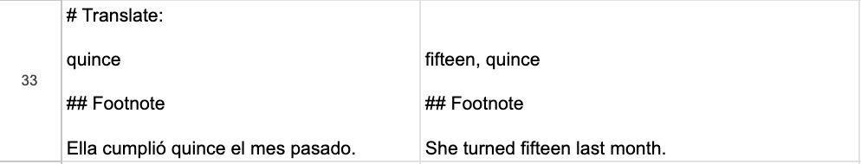

I don’t think “quince” is needed here. For some words, the second translation is a duplicate:

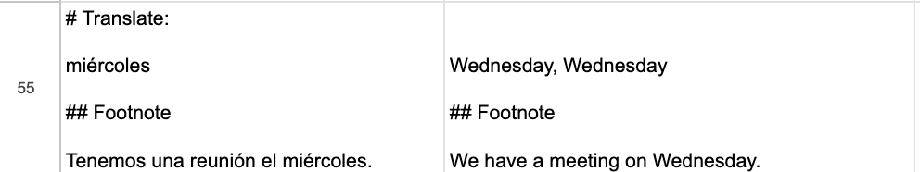

And for some others, it is straight up incorrect. Here, “sobrino” cannot ever mean “niece”, that’s “sobrina”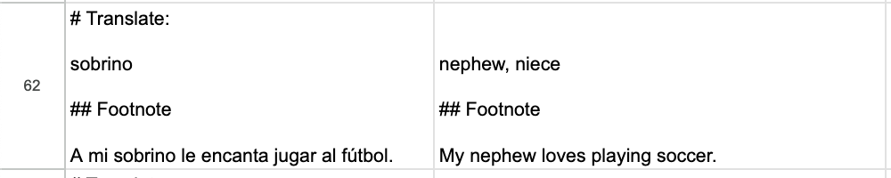

I deleted most of the second translations, and then added back only those that actually have two sufficiently distinct translations.

2) Making explicit that a word is a verb

I explicitly added many “to”’s to clarify that a word is a verb and not a noun. For example, translating “revisar” as “check” can be misleading, because people might think of, for instance, a bank check, while “to check” makes explicit that it’s a verb.

3) Word was not used in the sample sentence

In some sample sentences, the word was not used in the sentence. Here, “piense” is not part of the example sentence:

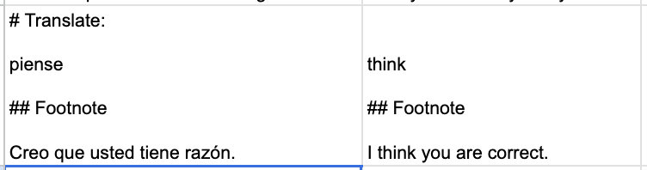

I made sure that all sample sentences mention the highlighted word.

4) Categorizing words to make them more distinct

Here, two words have the same translation, “fish”. I added “(meat)” and “(animal)” to their definitions, so that it’s clear that they refer to different ideas.

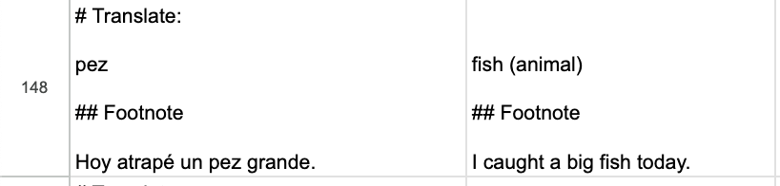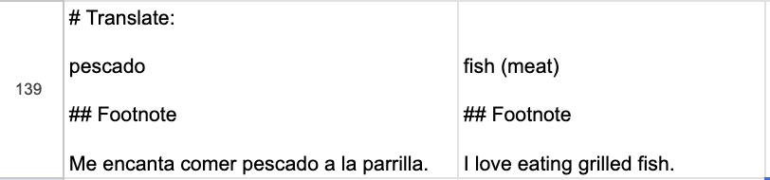

Where needed, I added either semantic qualifiers like the aforementioned, or grammatical, like “(noun)” or “(adjective)”

5) Removal of extra quotes

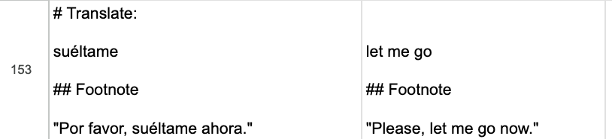

Most sample sentences do not have quotes, so I deleted them where they are present to have a standard format.

6) Correcting inaccurate sample sentences

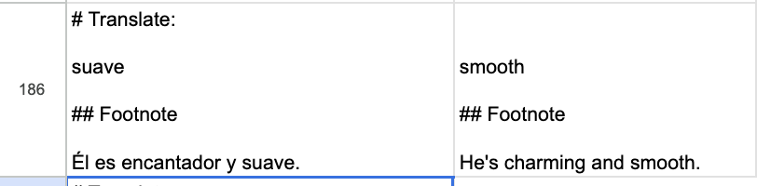

Here, “suave” does mean “smooth”, but it’s used to refer to objects and surfaces, not people. So “Él es suave” does not make sense in Spanish. I corrected these to have sentences that use the word in a way that we’d use in a normal Spanish sentence.

